Central Limit Theorem (CLT)  
  
The initial version of the CLT was coined by Abraham De Moivre, a French-born mathematician.  
  
In 1812, the concept was reintroduced by Pierre-Simon Laplace, another famous French mathematician.  
Laplace re-introduced the normal distribution concept in his work titled “Théorie Analytique des Probabilités”.  
  
The mathematician found that the average of independent random variables, when increased in number, tends to follow a normal distribution. At that time, Laplace’s findings on the CLT attracted attention from other theorists and academicians.  
  
Later in 1901, CLT was expanded by Aleksandr Lyapunov, a Russian mathematician.  
  
CLT performs a significant part in statistical inference. It depicts precisely how much an increase in sample size diminishes sampling error, which tells us about the precision or margin of error for estimates of statistics, for example, percentages, from samples.  
  
CLT disappoints when a distribution has a non-limited variance. These cases are rare yet might be significant in certain fields.  
  
Solidly, when you don’t have a clue about the distribution of certain data, at that point, you can utilize the CLT to presume their normality.  
  
The drawback of the CLT is that it is frequently utilized without checking the suspicions, which has been the situation in the finance domain for quite a while, assuming returns were normal, though they have a fat-tailed distribution, which characteristically carries a greater number of dangers than the normal distribution.  
  
Practical Applications  
In any ML problem, the given dataset represents a sample from the whole population. Using this sample, we try to catch the main patterns in the data. Then, we try to generalize the patterns in the sample to the population while making the predictions. CLT helps us to make inferences about the sample and population parameters and construct better machine learning models using them.  
  
Limitation  
·      population must have a finite mean and variance  
·      relationship established by CLT between features of population distribution and those of sampling distribution is applicable on mean only, and cannot be applied to var, std, mode, or median of samples.  
·      for skewed distribution, the sample size needs to be increased to something large  
·      sampling should be conducted in a random and independent fashion  
  
[#datascience](https://www.linkedin.com/feed/hashtag/?keywords=datascience&highlightedUpdateUrns=urn%3Ali%3Aactivity%3A6904336633093517312) [#statistics](https://www.linkedin.com/feed/hashtag/?keywords=statistics&highlightedUpdateUrns=urn%3Ali%3Aactivity%3A6904336633093517312) [#clt](https://www.linkedin.com/feed/hashtag/?keywords=clt&highlightedUpdateUrns=urn%3Ali%3Aactivity%3A6904336633093517312) [#machinelearning](https://www.linkedin.com/feed/hashtag/?keywords=machinelearning&highlightedUpdateUrns=urn%3Ali%3Aactivity%3A6904336633093517312)

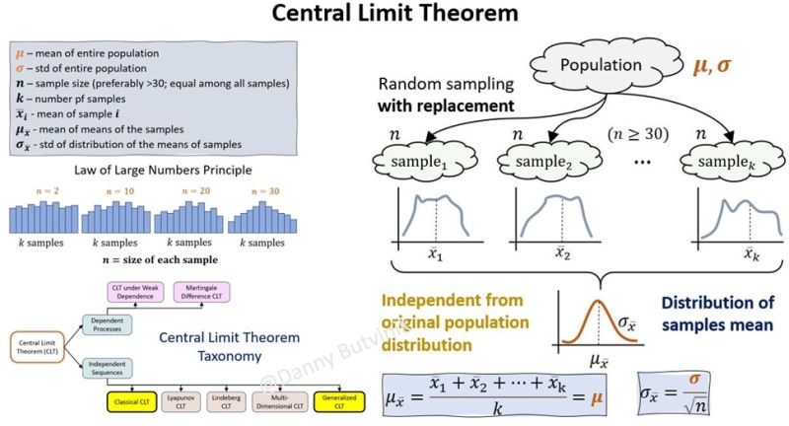

Activate to view larger imagewith Danny B.

* 47
* 1 comment